International Fall Semester
2024

Geopolitics French Language

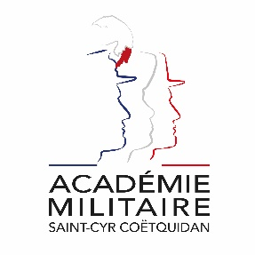
Military Academy of Saint-Cyr Coëtquidan

ERASMUS ID CODE | FGUER01
Contact | First Lieutenant (OF-1) OFFERLIN Charlie  Mail: cyr.international@st-cyr.terre-net.defense.gouv.fr  Phone: +33 2 97 70 73 75
Dates | Start: 16th September 2024  End: 17th January 2025  Arrival date: 11th September 2024 (Kindly respect this date)  Dates might evolve
Student Requirements | French language – B1
Application file | - Application form  - Medical Certificate  - Reduced Medical Booklet  - ID or Passport scan  - 1 ID photograph  Applications must be sent no later than 30th June 2024.
Meals & Accommodation | According to EMILYO-LoD 5 (framework), accommodation, meals, and other expenses in relation to the education are free of charge for members of European Union Basic Officer Education Institutions (http://www.emilyo.eu/node/982).

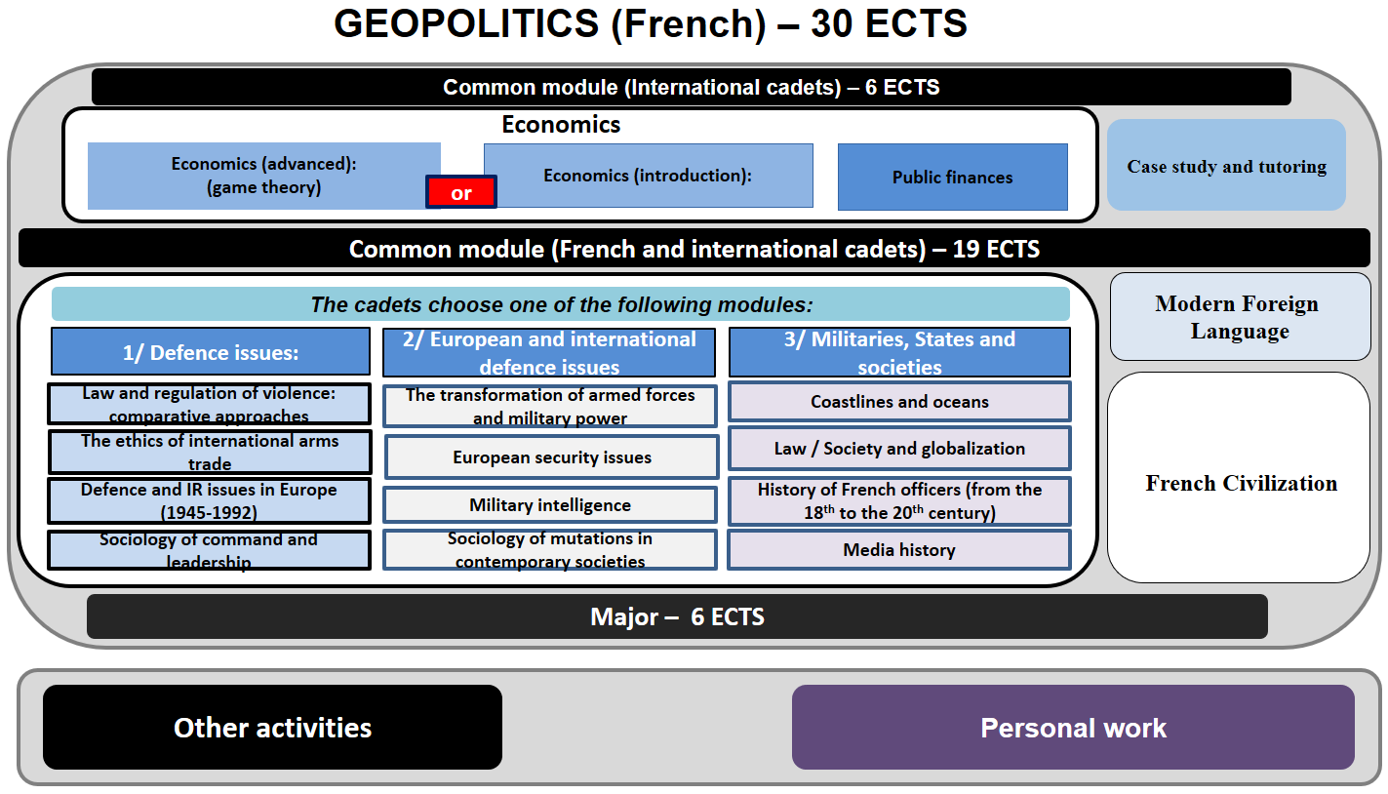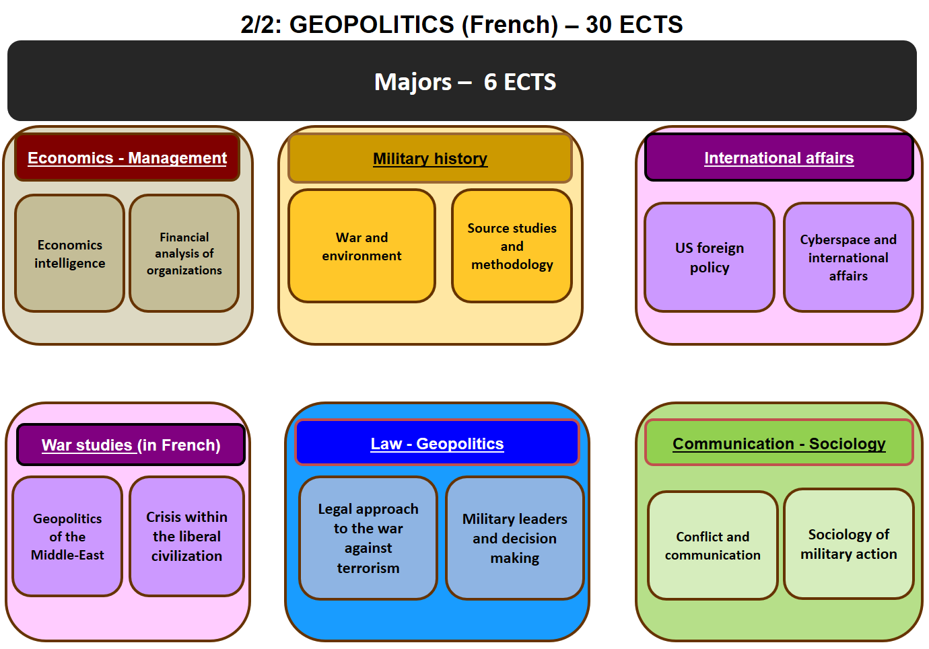

Courses Syllabus

COMMON MODULE (International cadets only)
- ECONOMICS
This course is aimed at cadets with a literary background, providing them with elements of economic aspects of defence industries and globalization.
- PUBLIC FINANCES
The purpose of this course is to introduce the main issues of state finances, by placing them in a historical, national and international perspective. The aim of this course is to give officer cadets the cultural foundations that allow them, beyond common places, to understand the regular debate in France on the legitimacy, performance and level of state spending, especially those dedicated to defence. This course will serve to present the main political and administrative institutions of the French state and situate the military framework within this environment that it “impacts” in many fields.
- CASE STUDIES AND TUTORATE

COMMON MODULE (French and international cadets)
- FRENCH CIVILIZATION
This course, delivered entirely in French is designed to provide foreign cadets with an understanding of French and French speaking culture, through geography, history, political institutions and cultural notions. Students will also be asked to work on a presentation in French on a topic of their choosing related to French culture or institutions.
- MODERN FOREIGN LANGUAGE (YOUR CHOICE)
- GERMAN
This semester aims to deepen the four language skills covered in the previous semester: oral and written comprehension and expression in the form of text studies and audio and video documents. This teaching provides an introduction to the knowledge of the foreign army and the military language.
- ARABIC
- Improvement of Syrian-Lebanese Arabic
- Syrian-Lebanese Arabic: deepening of basic grammatical and lexical structures, deepening of a basic lexicon to introduce oneself and to handle the structures of daily life.
- SPANISH
This semester aims to deepen the four language skills covered in the previous semester: oral and written comprehension and expression in the form of text studies and audio and video documents. This teaching provides an introduction to the knowledge of the foreign army and the military language.
- FRENCH (as foreign language)
This teaching aims to:
- Improve students' written and oral comprehension and expression to enable them to profitably follow military and academic courses and to produce the required assignments and test exercises.
- Prepare to French language PLS.
- ITALIAN
This semester aims to deepen the four language skills covered in the previous semester: oral and written comprehension and expression in the form of text studies and audio and video documents. This teaching provides an introduction to the knowledge of the foreign army and the military language.
- RUSSIAN
This second year of formation aims to deepen all the areas covered in S2, both from a linguistic and cultural point of view. It allows students to acquire, in writing and speaking, notions of military language. Students leaving for semester 5 in Russia can benefit from adapted counselling.

+ ONE TOPIC OUT OF THE FOLLOWING THREE:

1/ DEFENCE ISSUES
- LAW AND REGULATION OF REGULATION: COMPARATIVE APPROACHES
It is a complementary approach to the three components of legal discipline (history of law, private law and public law) which aims to shed light on the constraints imposed by law from an operational perspective: violence: historical and philosophical approaches, the military in the face of the law, regulation of the use of force in the international order: the hopes of the 20th century towards the challenges of the 21st century
- THE ETHICS OF THE INTERNATIONAL ARMS TRADE
Through this course, the aim is to study ethic rules underlying the use of weapons in past, present or future conflicts, including economic or informational. This module attempts to enlighten officer cadets on specific issues such as nuclear weapons, strategic bombing, cyber weapons, SALA or augmented soldier and different fields of employment such as immaterial fields or space.
- DEFENCE AND INTERNATIONAL RELATIONS ISSUES IN EUROPE (1945-1992)
This module aims to highlight the link between the post-war and cold war political crises, on the one hand, and the relations between European and extra-European powers. It must also help understand the construction of a European defence policy within the framework of transatlantic cooperation.
- SOCIOLOGY OF COMMAND AND LEADERSHIP
The objective of this course is to provide students with elements of reflection on two major dimensions of the exercise of their profession as officer: both command and leadership. This course approaches these notions scientifically by exploring their conceptions and the problems, theoretical or practical, that they pose. It will also involve questioning the way in which individuals are trained in these fields. Finally, as a corollary of command, decision making will also be the subject of part of this teaching. Indeed, it will be necessary to see why rational, well-trained, competent actors with the necessary information can be led to make absurd decisions and produce radical and persistent errors. The course will allow to explore the reasons and to make emerge the way to optimize the reliability of a decision and how to avoid the cognitive biases that effect every individual, as well as the collective logics at work.

2/ EUROPEAN AND INTERNATIONAL DEFENCE ISSUES
- THE TRANSFORMATION OF ARMED FORCES AND MILITARY POWER
This course highlights the contemporary military evolutions. On the one hand, regarding the use of armed force and military capabilities in a constantly changing operational environment. On the other hand, by comparing the doctrinal, organizational and capability choices of the armed forces in the contemporary strategic context.
- EUROPEAN SECURITY ISSUES
This course examines the E.U. policy of security and defence, European defence law actors and E.U. military missions.
- MILITARY INTELLIGENCE
This course focuses on the history of intelligence in the 20th century, starting from the men and the tactical level, to the strategic approach.
- SOCIOLOGY OF MUTATIONS IN CONTEMPORARY SOCIETIES
This course provides officer cadets with an introduction to the analysis of social issues posed by transformations in French society. The main topics covered are: the individual, social institutions and modernity, family and demography, the economy and the world of work, poverty, exclusion and integration, the reconstruction of beliefs. The course focuses for 75% on the challenges of developed societies, in particular France, and for 25% on the other countries of the European space. It offers student officers to develop a capacity for critical analysis of social issues in order to be able to situate themselves in society by developing their thinking. The pedagogy is based on different supports: the lecture, the documentary, texts to be discussed.

3/ MILITARIES, STATES AND SOCIETIES
- COASTLINES AND OCEANS
This course analyzes the challenges of climate change for the armed forces. It will deal with the emergence of climate security in international bodies (EU, NATO) and in military doctrines; the effects of climate change for the armed forces at the three levels of command; the expectations and representation of the French population regarding the involvement of the armed forces in the management of climate change, and in particular in the management of environmental disasters.
The cadets will have to write a paper on this topic at the end of the course.
- LAW / SOCIETY AND GLOBALIZATION
This course deals with the consequences of globalization on French society and aims to strengthen the knowledge of political concepts and the critical intelligence of officer cadets.
- HISTORY OF FRENCH OFFICERS (FROM THE 18TH TO THE 20TH CENTURY)
This module will allow students to better understand the behaviour of French officers from the end of the 18th century to the Algerian War. It will address the concepts of honour, military obedience and their relationship to recruitment and combat engagement to determine how officers are intellectually prepared to become a major player in the Nation.
- MEDIA HISTORY
The purpose of this course is to introduce non-specialist EOs to the functioning of the media and to the challenges brought by the current media revolution (web 2.0, social networks, etc.) To understand these issues, the course will endeavour to retrace the history of the media in the history of publication in the broad sense (from the invention of the printing press to the contemporary era).

MAJORS
ONE MAJOR TO BE SELECTED AMONG:

1/ ECONOMICS - MANAGEMENT
- ECONOMIC INTELLIGENCE
This course deals with the analysis of the mechanisms of contemporary competition (digital and globalized economy): competition on the market and outside the market, operations of influence, production and competition of standards, economic war.
- FINANCIAL ANALYSIS OF ORGANIZATIONS
Financial analysis refers to the methodical assessment of the financial situation of a company, a person or a project. The purpose of this analysis is to provide, from quantified information of various origins, a synthetic vision which brings out the reality of the situation and which must help the manager, the investor and the lender in their decision-making. The student should be able to carry out an analysis of the financial situation of an organization, an area which is very important in the current context.
This module is also designed as a preparation for the "Management simulation" module of S4.

2/ MILITARY HISTORY
- WAR AND ENVIRONMENT
The purpose of this course is to study the specificities of combat in mountainous, desert and jungle environments: lake of front, prioritization of the labor, surprise, operational constraints, logistics and tactics etc.
- SOURCE STUDIES AND METHODOLOGY
This module aims to introduce officer cadets to methodologies specific to military history, the history of international relations and geography by confronting them with the study of a diverse range of sources for the medieval, modern and contemporary periods.

3/ INTERNATIONAL AFFAIRS
- US FOREIGN POLICY
This course aims to provide officer cadets with analytical tools to understand the actors, issues and transformations of contemporary American leadership. It analyses the US foreign policy through literature and actual debates, mainly in English language.

- CYBERSPACE AND INTERNATIONAL AFFAIRS
This course analyses the modifications brought about by the expansion of Cyberspace in international and transnational political relations, it puts this political space into perspective, analyses the actors and the issues and outlines the contours of an analysis in strategic terms.

4/ WAR STUDIES
- GEOPOLITICS OF THE MIDDLE EAST
This seminar focuses on future conflicts in the Middle East. It analyses long-term developments in the region's borders as well as contemporary developments in the region's competing powers. The aim of the course is to study a particular country of the zone, different each year, in order to multiply the scales of analysis. The first hours consist of a regional focus, followed by 8 TD sessions. The exam consists of a paper to be handed in.
- CRISIS WITHIN THE LIBERAL CIVILIZATION
This seminar focuses on the study of crises in liberal civilization.

5/ LAW - GEOPOLITICS
- LEGAL APPROACHES TO THE WAR AGAINST TERRORISM
Legal approaches to international terrorism and legal approaches to the war on terror.
- MILITARY LEADERS AND DECISION MAKING
This course mentions the political and cultural consequences of the terrorist threat in Western Europe, focusing on the issue of internal security.

6/ COMMUNICATION - SOCIOLOGY
- CONFLICTS AND COMMUNICATION
The notion of conflict refers to a relational situation structured around opposition and antagonism. Whether at the level of individuals or groups, conflict has several intertwined dimensions. Considered as inherent to social relations or, on the contrary, as a disruptive element, conflict requires both its consideration and its resolution, notably through negotiation. Thus, in the resolution of conflicts (between individuals and groups), communication plays a major role. It will be a question here of analysing, by borrowing from sociology, anthropology and psychology, communication from an instrumental point of view, but also from a process point of view, emphasizing the individual, intra-group and inter-group dimensions.
- SOCIOLOGY OF MILITARY ACTION
This course will be taught by 2 teachers. The first part will deal with the characteristics of current missions by analysing the issues relating to the multinational, multifunctional dimensions, real-time media coverage and the issue of stress. The second part will examine military action from the point of view of war and post-conflict. It will address the following themes: the end of the war as an analyser of a temporality and a history of the aftermath of the war; the difficult reconstruction and reconciliation of war-affected territories (beyond the end of hostilities, a tendency to intensify violence, looting, destruction, the weight of community and religious identities as ingredients both for rupture and also for social ties). It will also discuss the challenges of demobilization at the scale of societies and the transition to peace with the economy of recognition and memory.

Application file documents:

- Application Form (p.10)

- Medical Certificate (p. 11)

- Reduced Medical Booklet (p. 12 – p.13)

Application Form

Military Academy of Saint-Cyr Coëtquidan
Please attach your head-and-shoulder photograph data.
Country of Origin:
Name of the Institution:

Course selected:
Geopolitics (ENG)
Geopolitics (FR) – Major: _____________________________
Science (ENG)

Male | Female | Rank | Surname | First name

Date of birth | Place of birth | Branch of Service | Major academic Field | Academic Year

Passport number | Phone number | e-mail address
ID number | Current address

Arrival at Rennes Airport (yes/no) | Arrival at Rennes rail station  (yes/no) | Arrival date (dd/mm/yy) | Time of arrival
Departure from Rennes Airport  (yes/no) | Departure from Rennes rail station  (yes/no) | Departure date (dd/mm/yy) | Time of departure

Special dietary or food requirements

Emergency contact/ Liaison staff:
Male | Female | Rank | Surname |  | First name
POC’s phone number |  |  |  | POC’s e-mail address

FRENCH MINISTRY OF DEFENCE

-------------------------
MILITARY HEALTH SERVICE

--------------------------
MEDICAL CERTIFICATE
(n°620-4/1)

SURNAME: FIRST NAME:

Birth date: Rank:

APTITUDES | Medical decision
General

Abroad & overseas

Paratrooper

Commando

Job’s restriction details
(if needed)

CONCLUSION: Date:
⁭ Aptitude without restrictions
⁭ Aptitude with restrictions Practitioner’s signature & stamp:
⁭ Inability

Reduced Medical Booklet

Surname: First Name:

Birth Date: Rank:

Medical Background
- Family:

- Medical:

- Surgical:

- Allergy:

Treatment:

Current Medical condition:

Job’s incapacity:

Height: Weight:

Blood Pressure: Pulse:

VACCINES:

TYPE | Date of 1st injection | 2nd injection | 3rd injection
BCG
Diphtheria-Tetanus-Polio-Pertussis
Meningitis (A + C)
Hepatitis B
Measles-Mumps-Rubella
INFLUENZAE (H1N1 and seasonal)
Meningococcal Tetravalent (A + C + Y + W135
Typhoid
Hepatitis A
Yellow fever

Date: Practitioner’s stamp and signature:

